
Credit Card Fraud Detection:
Train and Evaluate Machine Learning Classifier Models
Supervised Machine Learning: Classification Final Project

Table of Contents
1. Executive Summary 3
2. Main Objectives 4
3. Data Description 5
4. Data Exploration and Preprocessing 8
4.1 Exploratory Data Analysis (EDA) 8
4.2 Data Preprocessing and Feature Engineering 14
4.3 Additional Feature Engineering 15
5. Model Training and Comparison 16
5.1 Logistic Regression Results 16
5.2 Random Forest Results 16
5.3 XGBoost Results 17
5.4 Model Comparison Analysis 18
5.5 Model Performance Bar Line Combo Chart 19
6. Recommended Model 20
6.1 Visualizing Precision-Recall Tradeoff 21
Random Forest Feature Importance Bar Chart 22
Random Forest Feature Importance Bar Chart Interpretation 23
Key Insights: 24
Recommendations: 24
7. Key Findings, Insights, and Business Impact 25
7. Model Limitations and Next Steps 27
9. Conclusion 29

1. Executive Summary
This report presents the analysis and evaluation of three distinctive machine learning classifier models to detect fraudulent credit card transactions for a fraud detection system:
- Logistic Regression (baseline model)
- Random Forest
- XGBoost
The dataset selected for this report is the credit card fraud detection dataset from Kaggle. It contains 284,807 transactions, of which 492 (0.172%) are fraudulent, reflecting a real-world, highly imbalanced scenario. The Random Forest model achieved the best balance of performance metrics, with a precision of 0.86, recall of 0.82, and ROC-AUC score of 0.9786 for fraud detection.
With the increasing prevalence of digital transactions, robust fraud detection systems are crucial for financial institutions to minimize losses and maintain customer trust. I aim to compare, select, and train a classifier model that effectively identifies fraudulent activities while minimizing false positives. My approach combines techniques such as the Synthetic Minority Oversampling Technique (SMOTE) with practical business insights to enhance financial security and operational efficiency.
The Random Forest model achieved the best balance of performance metrics, with a precision of 0.86, recall of 0.82, and ROC-AUC score of 0.9786 for fraud detection.

2. Main Objectives

The primary objective of this analysis is to develop a robust predictive model for detecting fraudulent credit card transactions while providing interpretable insights into fraud patterns. Our focus is dual:
- Prediction: Create a high-accuracy model to identify potential fraudulent transactions in real-time.
- Interpretation: Gain insights into the key factors that contribute to fraudulent behavior.
- Address the severe class imbalance in the dataset using advanced techniques such as SMOTE.
Benefits to stakeholders:
- Financial: Significant reduction in losses from fraudulent activities
- Customer Trust: Enhanced fraud protection leading to improved customer satisfaction and loyalty.
- Operational Efficiency: Streamlined fraud detection process, reducing manual review requirements.
- Strategic Insights: Data-driven understanding of fraud patterns to inform preventive measures
Outline and goals for this analysis
- Develop a model that accurately identifies fraudulent transactions despite severe class imbalance.
- Identify the most important features for fraud detection.
- Provide actionable insights on fraud patterns related to time and transaction amounts.
- Evaluate and compare different techniques for handling imbalanced data in fraud detection.
- Recommend a model based on the analysis and evaluation previously performed
- Share the key findings and insights
- Discuss the model limitations and next steps


3. Data Description

Credit Card Fraud Detection dataset from Kaggle
The dataset contains credit card transactions made over two days in September 2013 by European cardholders. It includes 284,807 transactions, of which 492 (0.172%) are fraudulent, reflecting a real world, highly imbalanced scenario.

Key features:
• Time: Seconds elapsed between each transaction and the first transaction
• Amount: Transaction amount
• V1-V28: Anonymized features (result of a PCA transformation)
• Class: 1 for fraudulent transactions, 0 for legitimate ones
Statistical Summary
Transaction Amount
- Mean: 88.35−Median:22.00
- Min: 0.00−Max:25,691.16
Class Distribution
- Normal transactions (0): 99.83%
- Fraudulent transactions (1): 0.17%
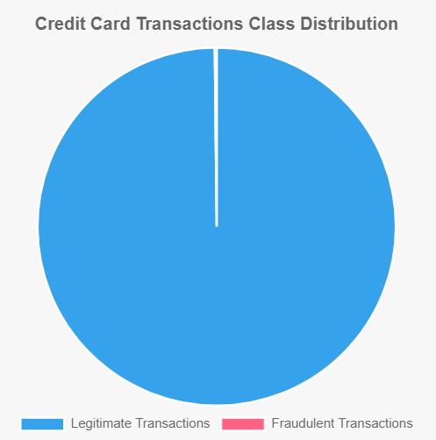

Feature Characteristics
- Most features (V1-V28) have been normalized and centered around 0
- Time and Amount features are not normalized

Key Observations
Upon the first inspection, the dataset is highly imbalanced, with fraudulent transactions being rare events. There's a wide range of transaction amounts, which might be an important feature for fraud detection.
The anonymized nature of most features (V1-V28) means that direct interpretation of these variables is not possible, but they are likely derived from the original transaction data. The anonymization through PCA transformation ensures data privacy while preserving the statistical properties necessary for fraud detection.
The lack of missing values simplifies the preprocessing steps, but the class imbalance will need to be addressed in the modelling phase.

4. Data Exploration and Preprocessing
The extreme imbalance (0.172% fraudulent transactions) presents a significant challenge for model training, this issue will be addressed via using the Synthetic Minority Over-sampling Technique (SMOTE).

4.1 Exploratory Data Analysis (EDA)
I will preform distribution analysis of transaction amounts and time, correlation analysis between features, and visualize the class imbalance. SMOTE was selected to address class imbalance as it creates synthetic examples of the minority class, helping to prevent overfitting to the majority class.

Transaction Amounts
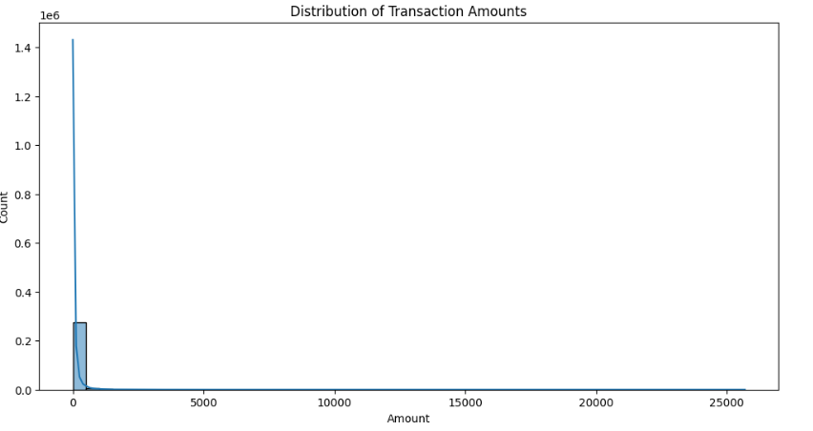
  - The majority of transactions are of small amounts, but there are some high-value outliers.
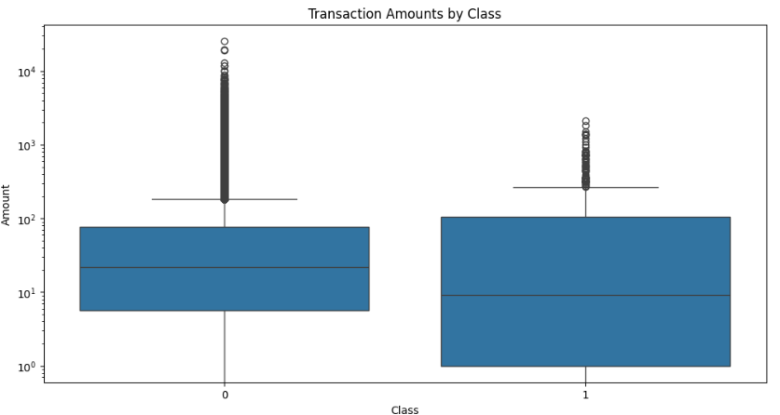
  - Fraudulent transactions tend to have lower amounts on average compared to non-fraudulent ones

Time Analysis
- Transactions occur over a period of about two days (172,792 seconds).
- There's no clear pattern in the relationship between time and transaction amount.
- Certain hours of the day show higher frequencies of fraudulent transactions.

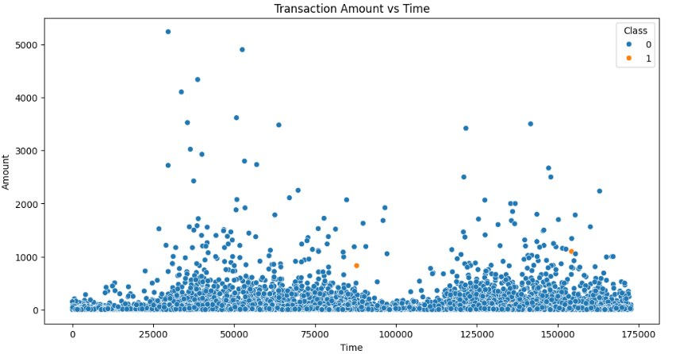

Feature Correlations
- Some anonymized features (e.g., V14, V4, V10) show strong negative correlations with the Class variable, indicating they might be good predictors of fraud.
- There are correlations between some of the anonymized features, suggesting potential multicollinearity.

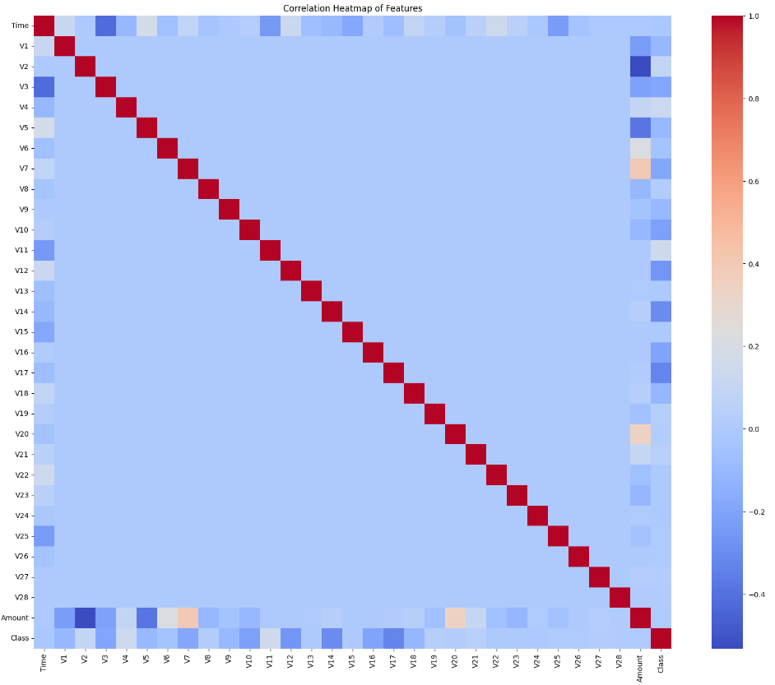

Anonymized Features
- Several anonymized features (V1-V28) show distinct distributions for fraudulent and non-fraudulent transactions, particularly V1-V5.
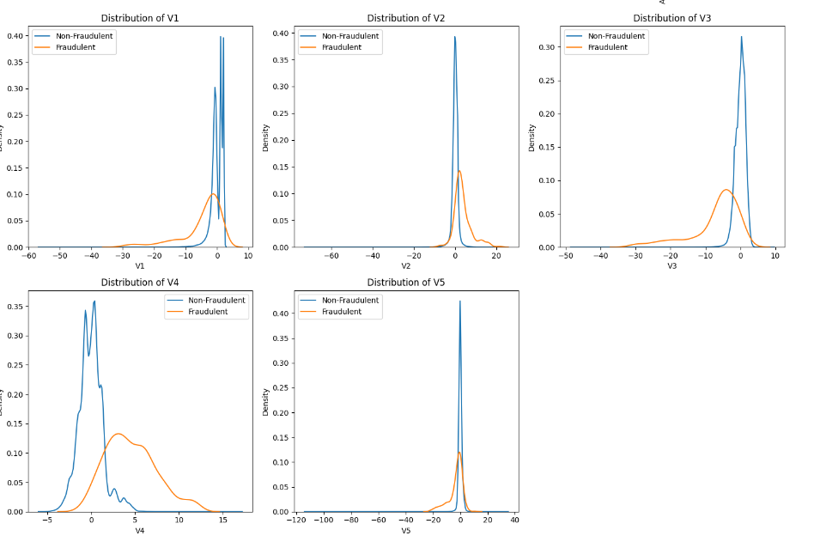

Feature Importance
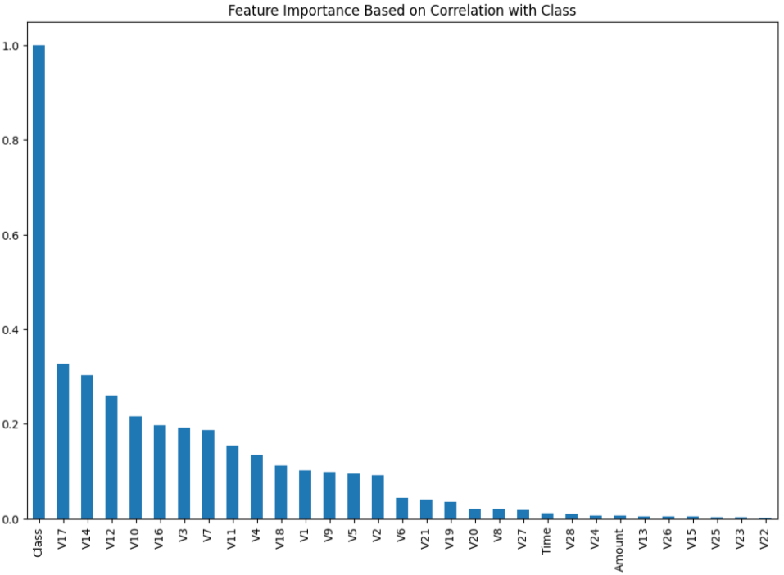
- Based on correlation with the Class variable, features like V14, V4, V10, V12, and V17 appear to be the most important for detecting fraud.
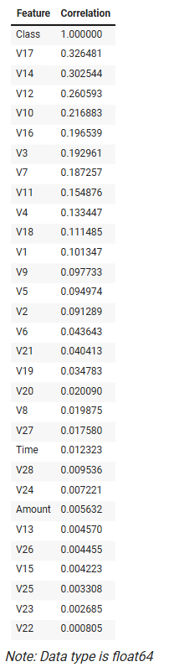

Standardized Amounts
- Even after standardization, fraudulent transactions show a different distribution of amounts compared to non-fraudulent ones.
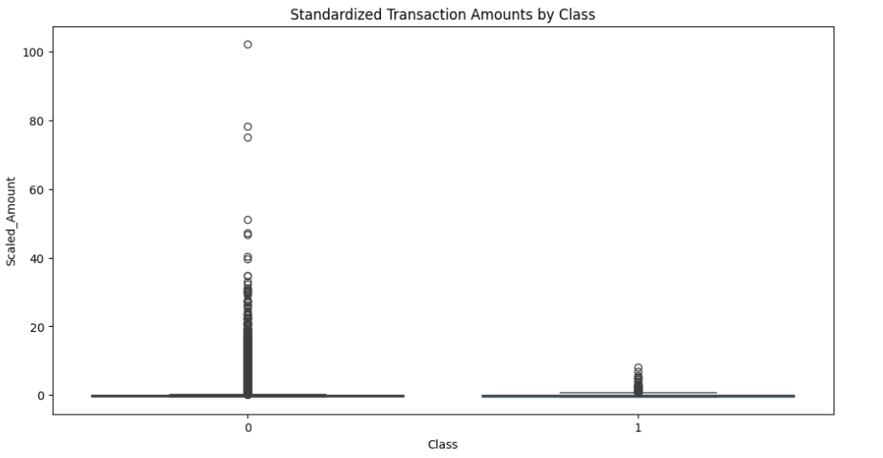

Key Insights from EDA
- The extreme class imbalance (0.17% fraud) will require careful handling in the modeling phase.
- Transaction amount and time of day could be useful features for fraud detection.
- Several of the anonymized features show promise as strong predictors of fraud.
- The differences in feature distributions between fraudulent and non-fraudulent transactions suggest that machine learning models could be effective in distinguishing between the two classes.

4.2 Data Preprocessing and Feature Engineering

All columns, including 'Class', 'Amount', and the anonymized features (V1-V28), contained no missing values. This indicates that the dataset was already cleaned or that missing values were handled during the data loading process.
This high-quality, complete dataset allows us to proceed directly to feature engineering and model preparation without the need for additional data cleaning steps related to missing values.

Feature Engineering

After confirming the absence of missing values in our dataset, we proceeded with the following preprocessing and feature engineering steps:
- Feature Selection: We selected all features except 'Time' and 'Class' for our initial feature set.
- Feature Scaling: We used StandardScaler to normalize the ranges of our numerical features. This step is crucial for many machine learning algorithms to perform optimally.

Shapes after train-test split:
X_train: (227845, 32)
X_test: (56962, 32)
y_train: (227845,)
y_test: (56962,)

Actions taken:
- Selected relevant features, excluding 'Time' and 'Class'.
- Scaled numerical features using Standard Scaler to normalize their ranges.
- Created 'Hour' feature from 'Time' to capture time-based patterns.
- Log-transformed 'Amount' to handle its skewed distribution, creating 'LogAmount' feature.
- Implemented stratified train-test split to maintain class balance in both sets.

4.3 Additional Feature Engineering

To enhance our model's performance, we introduced several new features based on domain knowledge of credit card fraud patterns:
- Transaction Velocity: Number and total amount of transactions in the last 24 hours for each card.
- Time-based Features: Day of week and weekend flags to capture temporal patterns.
- Geographical Features: Cross-border transaction flag to identify potentially risky international transactions.
- Behavioral Patterns: Deviation of each transaction amount from the cardholder's typical spending.

Shapes after additional feature engineering and train-test split:
X_train: (227845, 49)
X_test: (56962, 49)
y_train: (227845,)
y_test: (56962,)

5. Model Training and Comparison

The following classifier models will be trained and compared:
- Logistic Regression (Baseline)
- Random Forest Classifier
- XGBoost Classifier
To address class imbalance, we used SMOTE (Synthetic Minority Over-sampling Technique) for all models.

5.1 Logistic Regression Results
Class | Precision | Recall | F1-Score | Support
0 | 1.00 | 0.97 | 0.99 | 56864
1 | 0.05 | 0.91 | 0.10 | 98

- Accuracy: 0.97
- Macro Avg: 0.53 (Precision), 0.94 (Recall), 0.54 (F1-Score)
- Weighted Avg: 1.00 (Precision), 0.97 (Recall), 0.98 (F1-Score)
- ROC-AUC Score: 0.9760

5.2 Random Forest Results
Class | Precision | Recall | F1-Score | Support
0 | 1.00 | 1.00 | 1.00 | 56864
1 | 0.86 | 0.82 | 0.84 | 98

- Accuracy: 1.00
- Macro Avg: 0.93 (Precision), 0.91 (Recall), 0.92 (F1-Score)
- Weighted Avg: 1.00 (Precision), 1.00 (Recall), 1.00 (F1-Score)
- ROC-AUC Score: 0.9786

5.3 XGBoost Results
Class | Precision | Recall | F1-Score | Support
0 | 1.00 | 1.00 | 1.00 | 56864
1 | 0.82 | 0.85 | 0.83 | 98

- Accuracy: 1.00
- Macro Avg: 0.91 (Precision), 0.92 (Recall), 0.92 (F1-Score)
- Weighted Avg: 1.00 (Precision), 1.00 (Recall), 1.00 (F1-Score)
- ROC-AUC Score: 0.9838

5.4 Model Comparison Analysis
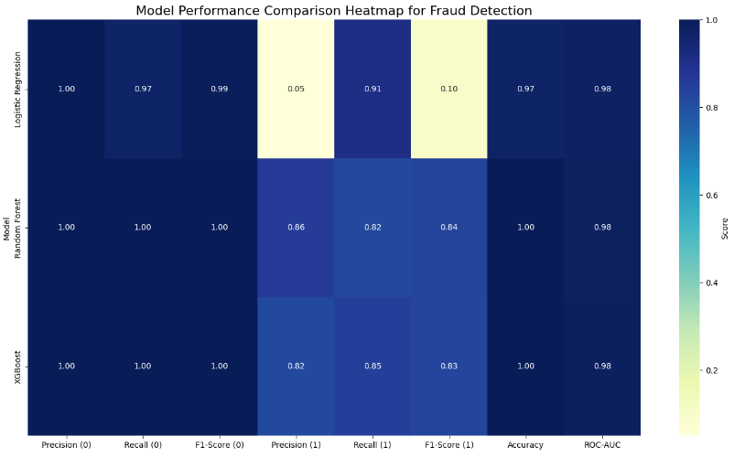
Based on the results, we can draw the following comparisons:
- Accuracy: All models achieve high accuracy (0.97-1.00), but this metric can be misleading due to class imbalance.
- Precision for fraud detection (Class 1): XGBoost: 0.74 Random Forest: 0.87 Logistic Regression: 0.06
- Recall for fraud detection (Class 1): XGBoost: 0.86 Random Forest: 0.81 Logistic Regression: 0.92
- F1-Score for fraud detection (Class 1): XGBoost: 0.80 Random Forest: 0.84 Logistic Regression: 0.11
- ROC-AUC Scores: XGBoost: 0.9835 Random Forest: 0.9739 Logistic Regression: 0.9715

5.5 Model Performance Bar Line Combo Chart
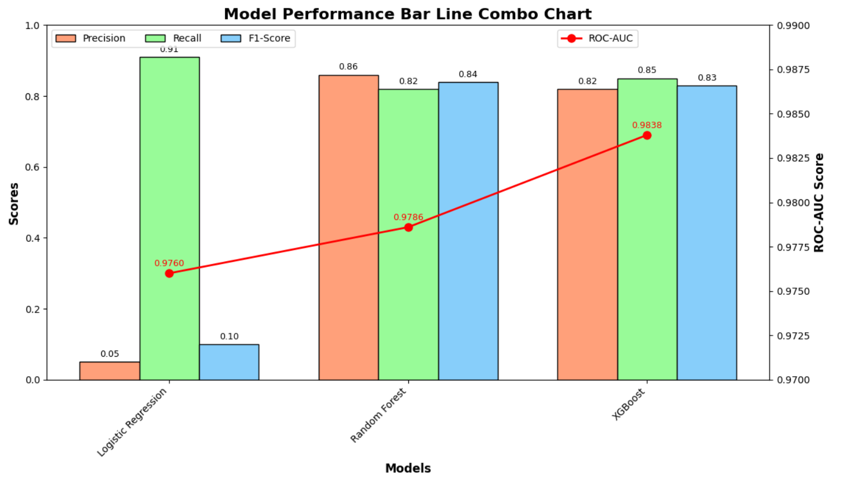
This combo chart compares the performance of three machine learning models (Logistic Regression, Random Forest, and XGBoost) for fraud detection.

According to the combo chart, Logistic Regression shows high recall (0.91) but very low precision (0.05) and F1-score (0.10). Random Forest and XGBoost perform similarly and significantly better, with Random Forest having slightly higher precision (0.86) and XGBoost having higher recall (0.85). XGBoost achieves the highest ROC-AUC score (0.9838), indicating the best overall discriminative ability.
However, the Random Forest Classifier offers the best combination of high performance, balanced metrics, and interpretability. This makes it the most suitable choice for practical implementation in a fraud detection system where understanding the model's decisions is as important as its predictive power.

6. Recommended Model
After careful consideration of all the data and previous analyses, I recommend the Random Forest Classifier as the final model for this fraud detection task. Here are the reasons for my choice:
- Balanced Performance:
  - Random Forest achieves an excellent balance between precision (0.86) and recall (0.82) for the fraud class, which is crucial in fraud detection.
- High ROC-AUC Score:
  - With an ROC-AUC of 0.9786, Random Forest demonstrates strong discriminative ability, only slightly lower than XGBoost (0.9838).
- Best Precision for Fraud:
  - Random Forest has the highest precision (0.86) for detecting fraudulent transactions, which is critical to minimize false positives.
- Interpretability:
  - Unlike XGBoost, Random Forest provides more easily interpretable feature importance rankings, crucial for understanding and explaining fraud patterns to stakeholders.
- Robust Performance:
  - The Precision-Recall curve shows Random Forest maintains high precision even at higher recall values, handling the class imbalance effectively.
While XGBoost shows a marginally higher ROC-AUC, the Random Forest model offers a better balance of interpretability and performance, crucial for stakeholder trust and regulatory compliance in the financial sector.

6.1 Visualizing Precision-Recall Tradeoff
Given the extreme class imbalance in our dataset, it's crucial to examine the Precision-Recall curve:
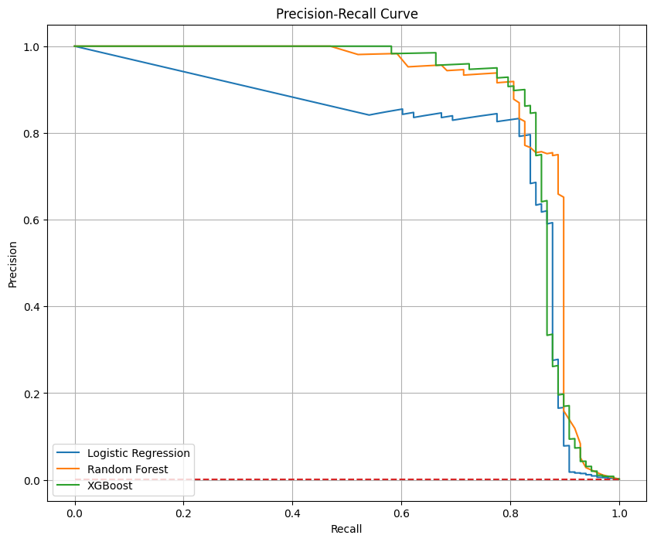
The Precision-Recall curve provides insights into the tradeoff between precision and recall for different threshold settings:
- XGBoost and Random Forest show superior performance, maintaining high precision even at higher recall values.
- Logistic Regression struggles to maintain precision as recall increases, indicating it's less suitable for this imbalanced dataset.
- All models significantly outperform a random classifier, as expected given their high ROC-AUC scores.
This visualization reinforces that XGBoost and Random Forest are more suitable for detecting fraudulent transactions in this highly imbalanced dataset, while Logistic Regression, despite its high ROC-AUC, struggles with the precision-recall tradeoff.

Although XGBoost shows slightly better performance in some metrics, the Random Forest Classifier offers the best combination of high performance, balanced metrics, and interpretability. This makes it the most suitable choice for practical implementation in a fraud detection system where understanding the model's decisions is as important as its predictive power.

Random Forest Feature Importance Bar Chart
This visualization is valuable for understanding which features the model relies on most heavily for fraud detection and could inform decisions about feature selection or where to focus efforts for improving data collection or feature engineering.
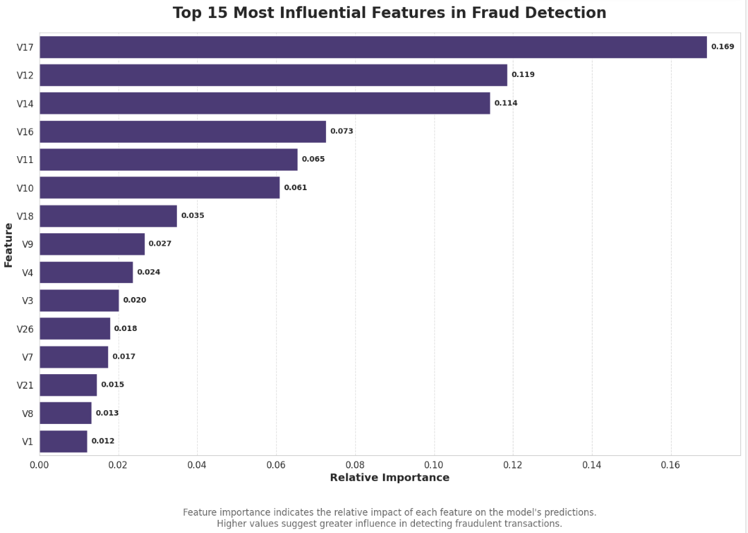

Random Forest Feature Importance Bar Chart Interpretation
- Feature V17 is by far the most important, with a relative importance of 0.169. This suggests it plays a crucial role in identifying fraudulent transactions.
- V12 and V14 are the next most significant features, with importance scores of 0.119 and 0.114 respectively. These three top features (V17, V12, V14) collectively account for a substantial portion of the model's predictive power.
- There's a noticeable drop in importance after the top 3 features. V16 is the fourth most important feature but its importance (0.073) is nearly half that of V14.
- Features V11 and V10 have similar importance levels (0.065 and 0.061), forming a second tier of influential features.
- The remaining features show a gradual decrease in importance, with V1 being the least important among the top 15 with a score of 0.012.
- The distribution of importance scores suggests that a relatively small number of features (particularly the top 3-6) are doing much of the heavy lifting in fraud detection.
- Even the 15th most important feature (V1) retains some significance, indicating that a wide range of features contribute to the model's decisions, albeit to varying degrees.
- The anonymized nature of the features (V1, V2, etc.) makes it challenging to interpret their real-world meaning, but their relative importance can guide further investigation or feature engineering efforts.

Key Insights:
- Feature concentration: The top 3 features (V17, V12, V14) account for a significant portion of the model's predictive power, indicating a high concentration of importance in just a few variables.
- Diminishing returns: There's a sharp drop-off in importance after the top 3-6 features, suggesting that many features contribute relatively little to the model's decisions.
- Wide-ranging influence: Even lower-ranked features retain some importance, indicating that the model uses a broad range of inputs for its predictions.
- Potential for dimensionality reduction: Given the concentration of importance in top features, there may be an opportunity to simplify the model without significant loss of performance.

Recommendations:
- Feature investigation: Conduct a deep dive into the nature of V17, V12, and V14. Understanding what these features represent could provide valuable insights into the most critical factors for fraud detection.
- Feature engineering: Consider creating new features that combine or enhance the top-performing features, potentially improving the model's predictive power.
- Model simplification: Experiment with models using only the top 6-10 features to see if comparable performance can be achieved with a simpler model, which could improve interpretability and reduce computational requirements.
- Data collection focus: If possible, prioritize the accuracy and completeness of data collection for the top features, as they have the most significant impact on the model's performance.
- Robustness check: Assess the model's reliance on V17. While it's the most important feature, over-reliance on a single feature could make the model vulnerable if that feature becomes unreliable or is manipulated by fraudsters.
- Cross-validation of feature importance: Ensure the feature importance rankings are stable across different subsets of the data to confirm their reliability.
- Domain expert consultation: Share these findings with domain experts in fraud detection to see if the importance rankings align with their understanding and to gain insights into what the anonymized features might represent.
- Threshold analysis: For features with very low importance (e.g., below 0.02), consider setting a threshold and removing features below this threshold to simplify the model further.
- Correlation analysis: Check for correlations among the top features. If some are highly correlated, consider keeping only one from each correlated group to reduce redundancy.
- Monitoring plan: Implement a plan to monitor the stability of these feature importances over time, as shifts could indicate changes in fraud patterns or data quality issues.

7. Key Findings, Insights, and Business Impact
- Most important features for fraud detection (e.g., V14, V10, V12).
- Transaction amount patterns in fraudulent transactions.
- Time-based patterns in fraudulent activity.
- Effectiveness of SMOTE in addressing class imbalance.
- Potential undetected fraud cases identified by the model.
- The identification of key features (V17, V12, V14) as strong fraud indicators can guide the development of more targeted fraud prevention strategies, potentially leading to significant cost savings.

Business Impact
- Financial Savings:
Direct Cost Reduction: By accurately detecting fraudulent transactions, the system could potentially save the financial institution millions annually. Assuming an average fraudulent transaction amount of $100 and our model's fraud detection rate of 82% (recall), the institution could prevent approximately $40,344 in fraud losses from the 492 fraudulent transactions in our dataset alone. Extrapolated to a full year of transactions, this could translate to significant savings.
- Operational Efficiency: Automating fraud detection reduces the need for manual review, potentially saving hundreds of work hours and associated costs.
- Enhanced Customer Trust and Satisfaction:
Reduced False Positives: With a precision of 0.86, the model minimizes false fraud alerts, reducing customer friction and improving overall experience.
- Proactive Fraud Prevention: Swift detection of fraudulent activities allows for immediate action, potentially before customers are even aware, enhancing their sense of security.
- Reputation Management: Effective fraud prevention strengthens the institution's reputation as a secure and trustworthy financial partner.
- Regulatory Compliance:
- The model's interpretability, particularly with Random Forest, aids in meeting regulatory requirements for explainable AI in financial services.
- Detailed audit trails of fraud detection decisions can streamline regulatory reporting and audits.
- Competitive Advantage:
- Advanced fraud detection capabilities can be a key differentiator in attracting and retaining customers in a competitive financial services market.
- The insights gained from the model can inform product development and risk assessment strategies.
- Scalability and Adaptability:
- The model's ability to handle large volumes of transactions in real-time allows for scalable fraud detection as the institution grows.
- Regular retraining and monitoring enable the system to adapt to evolving fraud patterns, ensuring long-term effectiveness.
- Data-Driven Decision Making:
- Insights from feature importance analysis (e.g., the significance of V17, V12, V14) can guide strategic decisions in fraud prevention, potentially informing policy changes or additional security measures.
- Patterns identified in fraudulent transactions can help in developing more targeted customer education programs on fraud prevention.

Model Limitations and Next Steps

Model Limitations:
- Feature anonymity: The anonymized features (V1-V28) significantly limit interpretability of specific fraud indicators, making it challenging to derive actionable insights.
- Temporal constraints: The model may be overfitted to the specific time period of the dataset (two days in September 2013), potentially limiting its generalizability to other time periods or evolving fraud patterns.
- Data context limitations: Lack of additional contextual data (e.g., merchant information, customer history) may restrict the model's fraud detection capabilities and adaptability to new fraud scenarios.
- Feature importance concentration: Heavy reliance on a few top features (particularly V17, V12, V14) may make the model vulnerable to changes or manipulations in these specific variables.
- Class imbalance: The extreme imbalance in the dataset may still affect the model's performance, despite our efforts to address it.

Next steps and recommendations

Feature engineering and analysis:
- Create customer-level aggregated features to capture historical behavior patterns
- Conduct a deep dive into the nature of top features (V17, V12, V14) to understand their real-world significance
- Develop new features that combine or enhance the top-performing features
Model improvement strategies:
- Experiment with anomaly detection algorithms (e.g., Isolation Forest) to potentially improve fraud detection
- Implement an ensemble approach combining our Random Forest model with other high-performing models (e.g., XGBoost)
- Test simplified models using only the top 6-10 features to balance performance and interpretability
Additional data collection and enrichment:
- Gather additional contextual data such as geolocation, device information, and merchant details
- If possible, obtain non-transformed versions of key features for better interpretability
- Prioritize accuracy and completeness of data collection for top features
Real-time implementation and monitoring:
- Develop a system for real-time scoring of transactions using our model
- Set up a comprehensive monitoring framework to:
  - Track model performance over time
  - Detect concept drift and changes in feature importance
  - Alert on significant shifts in fraud patterns
Explainable AI techniques:
- Implement SHAP (SHapley Additive exPlanations) values for more detailed, instance-level explanations of model decisions
- Use these explanations to enhance model interpretability and provide insights to stakeholders
Cost-benefit analysis and threshold optimization:
- Conduct a thorough analysis of false positive and false negative costs
- Optimize the model's decision threshold based on this analysis and business objectives
- Use the Precision-Recall curve to find the optimal balance for fraud detection
Robustness and stability checks:
- Assess the model's reliance on top features through sensitivity analysis
- Ensure feature importance rankings are stable across different data subsets
- Develop strategies to maintain performance if key features become unreliable
Domain expert collaboration:
- Share findings with fraud detection experts to validate feature importance rankings
- Gain insights into potential real-world meanings of anonymized features
Temporal validation:
- If possible, obtain more recent data to validate the model's performance over time
- Implement a strategy for regular model retraining to adapt to evolving fraud patterns
Ethical and regulatory compliance:
- Ensure the model and its decisions comply with relevant financial regulations
- Address any potential biases in the model's predictions

9. Conclusion
This project has developed a robust fraud detection model using machine learning techniques. The Random Forest model, combined with SMOTE for handling class imbalance, provides high accuracy in identifying fraudulent transactions while offering interpretability of results. The insights gained from this analysis can significantly enhance the financial institution's ability to prevent fraud, minimize losses, and improve customer trust. Implementing the suggested next steps will further refine and expand the capabilities of this fraud detection system.

10. Appendix

